|  |
| --- |
| **Argentis Consulting** |
| **Apparel & Footwear** |
| Design and Concept |

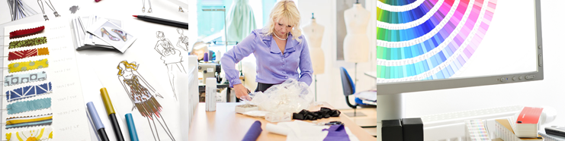

**www.sapapparel.com**

INDEX

1 Mood Board 3

1.1 Source Folder Setup 3

1.2 Mood Board creation 4

2 Design 5

2.1 New Design Creation 5

DESIGN AND CONCEPT

# Mood Board

A mood board is a tool used by designers to help them get a good idea of what their clients are looking for and place where they can have everything that inspires them for a new season. Mood boards are basically collages of items such as photographs, sketches, clippings, fabric swatches and color samples.

A fashion mood board usually has sketches of garments as the main focus of the board. Fashion boards may also have magazine clippings or other sketches of what inspired the designer such as pictures of ocean waves for the design of a dark blue silk gown. Trimming details and ribbon could also be on a fashion board.

Mood boards are a great way for designers to present their take on a theme to clients. For example, if a client tells a designer that he or she wants something cozy or airy those feelings could be created in many different ways. By putting the ideas on a mood board first, the designer can make sure the client likes the ideas.

## Source Folder Setup

Go to Apparel & Footwear —> Administration —> Setup —> General Settings —> Path

There, select the folder where you will have access to the files. This can be a folder that is a common repository for the people who are creating the mood board.

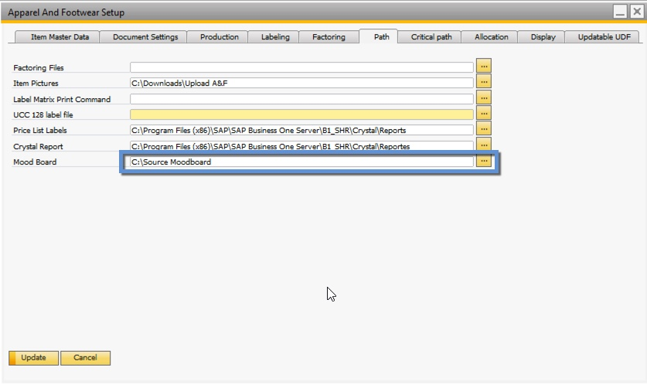

## Mood Board creation

1. Define a Code for the Mood board
2. Define the Theme for the Mood board
3. Select a Season (The season needs to be already defined in the system)
4. Select a Division (The division needs to be already defined in the system)
5. Type a description
6. Click on the photograph icon and the folder defined as source folder will open. Then select a picture and click on Open

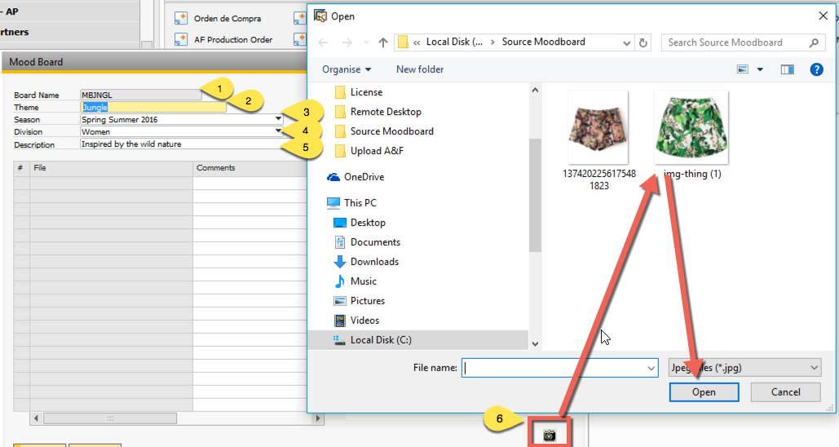

1. If desired, you can add a comment to the picture just attached
2. Finally, click on Add to create the Mood board

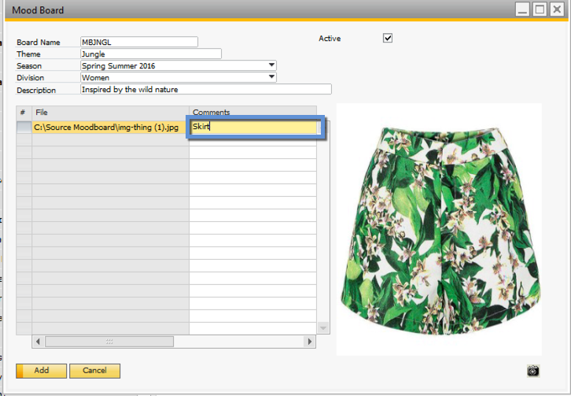

# Design

## New Design Creation

Now the user can create a style with DESIGN status avoiding to add color and sizes and also be flexible to update style code until the style is approved and final code is assigned.

You can create a new Design just simply right clicking on a file from the mood board and choosing Create Style Status Design or go to Apparel & Footwear 🡪 Design and Concept 🡪 Design Option

.

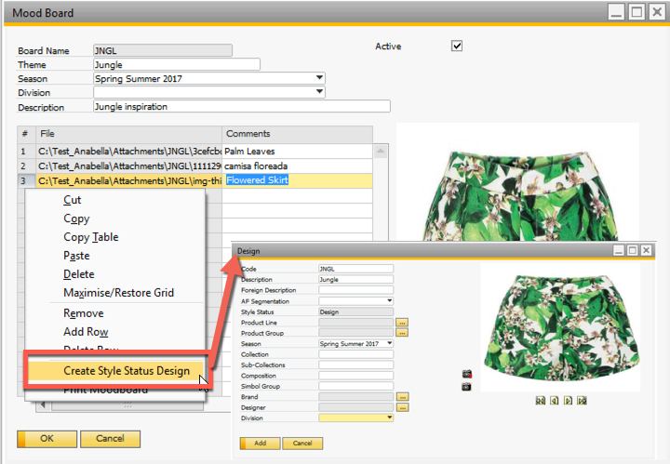

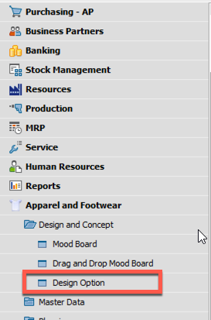

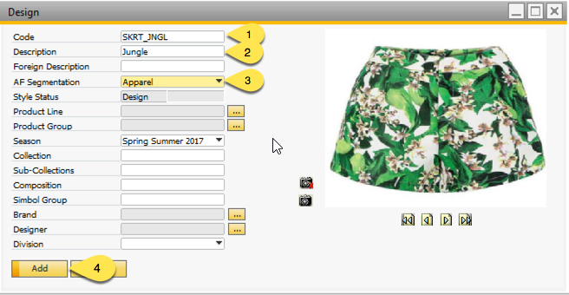

1. You can change the Design Code
2. You can change the Design Description
3. You must choose a Segmentation
4. Finally Click on Add.

The design styles options are also display in the style category tree view.

In this style’s PDM window it will not be possible to modify anything unless it changes from being a design to a style. This can be done by changing the status from the Design Option window.



**www.argentisconsulting.com**

**Argentis Consulting** is dedicated to the development, distribution and support of recognized certified solutions for SAP Business One, as an SSP (Software Solution Provider) with a Gold Partner status.

**CONTACT INFORMATION**

|  |  |
| --- | --- |
| **USA**  9744 NW 45th Lane  Doral, FL 33178  info@argentisconsulting.com | **ARGENTINA**  Ávila y Zarate 2048  Cerro de la Rosas, Córdoba,  CP 5009  Córdoba - Argentina  info@argentisconsulting.com |
| **CARIBEAN**  City View Plaza – Suite 301  48 Road 165  Guaynabo, PR. 00968  Puerto Rico  caribe@argentisconsulting.com | **SPAIN**  C/ Juan Bravo N° 3 A 28006  Phone: (+34) 91 123 7263  Madrid - Spain  info@argentisconsulting.com |